

|  |  |
| --- | --- |
| **Name: Sayyed Sohail Rashid** | **Course Name: DC-LAB** |
| **Class: BE-CO** | **Batch: 01** |
| **Roll no: 18CO48** | **Experiment No: 05** |

**Aim : To Implement the Bully Algorithm.**

**Code:**

BullyAlgoExample2.java

import java.util.Scanner;

// create process class for creating a process having id and status

class Process{

// declare variables

public int id;

public String status;

// initialize variables using constructor

public Process(int id){

this.id = id;

this.status = "active";

}

}

// create class BullyAlgoExample2 for understanding the concept of Bully algorithm

public class BullyAlgoExample2 {

// initialize variables and array

Scanner sc;

Process[] processes;

int n;

// initialize Scanner class object in constructor

public BullyAlgoExample2(){

sc= new Scanner(System.in);

}

// create ring() method for initializing the ring

public void ring(){

// get input from the user for processes

System.out.println("Enter total number of processes of Processes");

n = sc.nextInt();

// initialize processes array

processes = new Process[n];

for(int i = 0; i< n; i++){

processes[i]= new Process(i);

}

}

// create election() method for electing process

public void performElection(){

// we use the sleep() method to stop the execution of the current thread

try {

Thread.sleep(1000);

} catch (InterruptedException e) {

e.printStackTrace();

}

// show failed process

System.out.println("Process having id "+processes[getMaxValue()].id+" fails");

// change status to Inactive of the failed process

processes[getMaxValue()].status = "Inactive";

// declare and initialize variables

int idOfInitiator = 0;

boolean overStatus = true;

// use while loop to repeat steps

while(overStatus){

boolean higherProcesses = false;

// iterate all the processes

for(int i = idOfInitiator + 1; i< n; i++){

if(processes[i].status == "active"){

System.out.println("Process "+idOfInitiator+" Passes Election("+idOfInitiator+") message to process" +i);

higherProcesses = true;

}

}

// check for higher process

if(higherProcesses){

// use for loop to again iterate processes

for(int i = idOfInitiator + 1; i< n; i++){

if(processes[i].status == "active"){

System.out.println("Process "+i+"Passes Ok("+i+") message to process" +idOfInitiator);

}

}

// increment initiator id

idOfInitiator++;

}

else{

// get the last process from the processes that will become coordinator

int coord = processes[getMaxValue()].id;

// show process that becomes the coordinator

System.out.println("Finally Process "+coord+" Becomes Coordinator");

for(int i = coord - 1; i>= 0; i--){

if(processes[i].status == "active"){

System.out.println("Process "+coord+"Passes Coordinator("+coord+") message to process " +i);

}

}

System.out.println("End of Election");

overStatus = false;

break;

}

}

}

// create getMaxValue() method that returns index of max process

public int getMaxValue(){

int mxId = -99;

int mxIdIndex = 0;

for(int i = 0; i<processes.length; i++){

if(processes[i].status == "active" && processes[i].id >mxId){

mxId = processes[i].id;

mxIdIndex = i;

}

}

return mxIdIndex;

}

// main() method start

public static void main(String[] args) {

// create instance of the BullyAlgoExample2 class

BullyAlgoExample2 bully = new BullyAlgoExample2();

// call ring() and performElection() method

bully.ring();

bully.performElection();

}

}



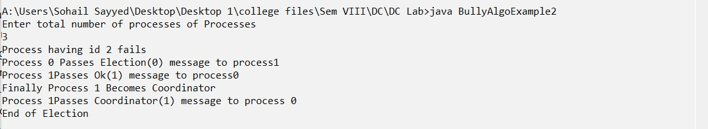

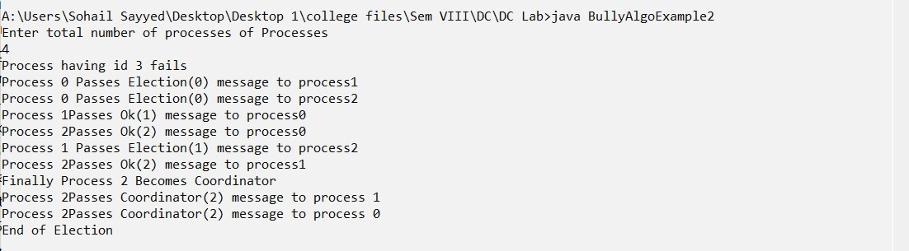

**Conclusion:**

Bully Algorithm has been executed successfully and gives the required output.